NATURE OF THE CUSTOMERS

FOR

REVIEW MANAGEMENT SYSTEM

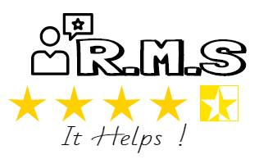

Prepared by RMS members:

RISHABH GANGWAR (U101114FCS116)

SURAJ PRAKASH SHARMA (U101114FCS144)

SANDEEP KUMAR (U101114FCS213)

RAJAT SINHA (U101114FCS114)

SAJAL KUMAR MISHRA (U101114FCS171)

**RATING MANAGEMENT SYSTEM (RMS)** is designed for all the university people whether he is a faculty member, student or guest. It’s a huge platform where the customers can rate on daily basis about the quality and maintenance of the different components and services of the university. They can also give their suggestions and share their requirements.

This software will create a linkage between the customers and the service management team. Customers can rate the services and can also put forward their reviews in just one click. On the other hand, the service management team will also be benefited because they can fulfill the needs of their customers without personally interacting with them and can manage easily.

The basic idea of this product is to reach each and every person and get to know the problems that are to be sorted out. This web application will enable the university to know the status of all their services on one platform. This rating system is very commonly used in different fields and using it for rating the components of the university is a new refreshing idea that will prove to be very helpful in managing the services in the near future.

|  |  |  |
| --- | --- | --- |
| S.No | User Class | Description |
| 1. | Students | Students can rate the mess food, laundry services, general stores, and sports facilities etc in order to meet their needs. |
| 2. | Faculty | Teachers can also rate the different components and submit their kind suggestions. |
| 3. | Guest | The students or faculty members who are there in the university for some days can also rate the components on daily basis. |

This software is built for rating the different components of the university, but it can also be used at large scale by performing some changes that can be used in different fields and can facilitate many services for the customers.

Through this, the common people can directly interact with the head of the department and can put forward their point of view.